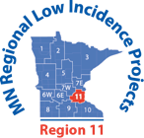

**Interpreting High-Level Math Concepts**

**Sponsored by Regional Low Incidence Projects – Region 11**

**Rescheduled**

Online registration deadline: December 17, 2023

**BrightWorks Virtual Training**

**Thursday, December 14, 2023**

**5:30 p.m. – 7:30 p.m.**

**For:** K-12 ASL **Educational** Interpreters, Teachers of Deaf/Hard of Hearing, Related Service Providers who work with Deaf/Hard of Hearing Students

**The workshop will be presented in ASL.**

**COST: No cost for ASL Educational Interpreters currently working within a Minnesota K-12 district setting, Teachers of Deaf/Hard of Hearing, and Related Service Providers who work with Deaf/Hard of Hearing Students.**

Registration will be checked for qualified registrants**.**

All others who are "not" Minnesota school district participants and fall outside our target audience (including freelance interpreters not in educational settings) are welcome to attend for a fee of $25.

**Registration Link:** <https://metroecsu.myquickreg.com/register/event/event.cfm?eventid=17125>

Virtual – Zoom Registration Link for participation will be emailed to Registrants.

**Workshop description:** There is increasing emphasis on the importance of higher math concepts. Many interpreters and teachers have different signs for certain mathematical terms, and it is possible that a lack of standardization may influence learning. This workshop will demonstrate signs for real-life math terms so teachers and interpreters can be a part of the standardization of ASL signs.

**Presenter: Paul Glaser** is an Ohio native, however, Washington State is his home. Paul graduated high school from St. Rita School for the Deaf as valedictorian. He then attended Gallaudet University where he earned a bachelor’s degree in mathematics and communications studies in 2003. Paul went on to attend Rochester Institute of Technology, achieving his master’s degree in Deaf Education with a focus in mathematics in 2005. During his graduate career, he focused on researching and collecting math signs for K-12 settings. Since 2005, he has taught mathematics to Deaf students in K-12 settings and at the college level. Paul also developed a learning program to teach math signs to interpreters. It was through teaching that Paul came to realize his love for interpreting. In the early 2010s, Paul began to take several interpreting classes and workshops in the greater Seattle area, at Gallaudet University, and at Spokane Falls Community College, and became a Certified Deaf Interpreter in 2014 Currently, Paul works at the Center of Deaf and Hard of Hearing Youth in the state of Washington as a STEM Teacher of the Deaf. Paul worked at Sorenson Communications as an Interpreter Educator in the Professional Development department for 6 years. In addition, Paul specializes in teaching and mentoring educational interpreters in various topics, especially mathematics.

**Register:** <https://metroecsu.myquickreg.com/register/event/event.cfm?eventid=17125>

**Registration Questions:** Gail Jankowski | [click here to send Gail Jankowski an email](http://gail.jankowski@metroecsu.org/) [message](http://gail.jankowski@metroecsu.org/) **Program Questions:** Ann Mayes | [click this to send Ann Mayes an email](http://ann.mayes@metroecsu.org/) [message](http://ann.mayes@metroecsu.org/)

ASLIS is an Approved RID CMP Sponsor for continuing education activities. This workshop is offered for 0.2 RID CEUs at the little/none or some content knowledge level.

ACET: Association Continuing Education Tracking American Sign Language Interpreter Services (ASLIS) logo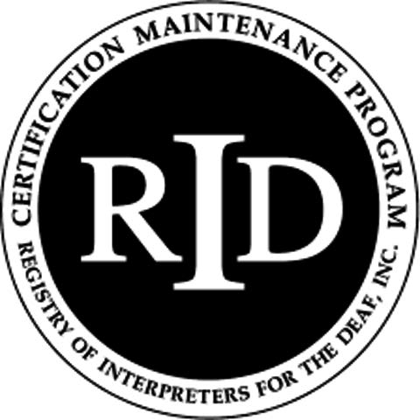

*This training is funded with a grant from MDE using federal funding, CFDA 84.027A, Special Education - Grants to States. This event does not necessarily represent the policy of the federal Department of Education or the state Department of Education. You should not assume endorsement by the federal or state government.*